1. Purpose

This document provides the instruction to setup an OAGIS Repository database. At this time, an implementation is provided for the Oracle Database Management System (DBMS). The installation of the DBMS is out of scope of this document.

2. Requirements

1. Oracle 10g or higher installed. The user executing this database script has sufficient grants to create databases and tables.

2. A database created in the DBMS. In the instruction below, the database name is assumed to be *oagsrt_revision*. If a database has not yet been created, the instruction at [Creating Database](http://dev.mysql.com/doc/refman/5.5/en/creating-database.html) may be useful.

3. Two SQL scripts included in this distribution, one for creating the database schema and the other one for populating data into the database. The script for creating the database schema has the file name *schema-oracle.sql*. The script for populating the data has the file name *data-oracle.sql*.

3. Setting up

Execute the database schema script and then data population script using a DBMS client.

3.1. Example using Oracle SQL Developer

Oracle SQL Developer can be downloaded [here](http://dev.mysql.com/downloads/workbench/).

3.1.1. Create New Connection

If a connection to the desired database, e.g., *oagsrt_revision*, does not exist create one as follows.

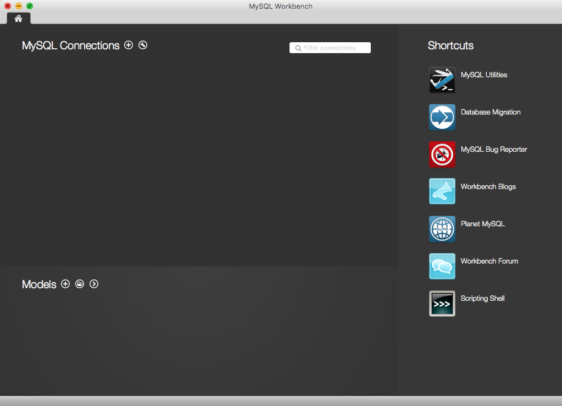

[ Figure 1. The Home Screen of MySQL Workbench ]

This screen, Figure 1., appeared when you started MySQL Workbench. To make new connection configuration, you can click [+] button by ‘MySQL Connections’ label on the left-top screen.

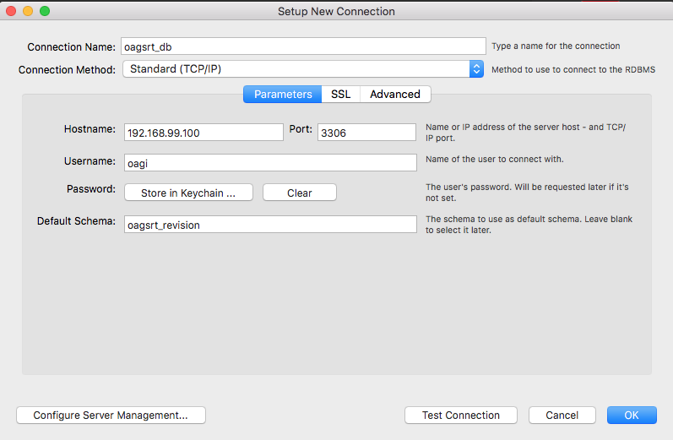

[ Figure 2. The dialog to create new connection ]

Fill in a connection name and provide all information to access the database.

In this example, as can be seen in Figure 2., the connection name has been set as *oagsrt_db*, *192.168.99.100* as Hostname, *3306* as Port, *oagi* as Username and *oagsrt_revision* as Default Schema (this is the database prepared earlier). These parameters shall be set based on your environments.

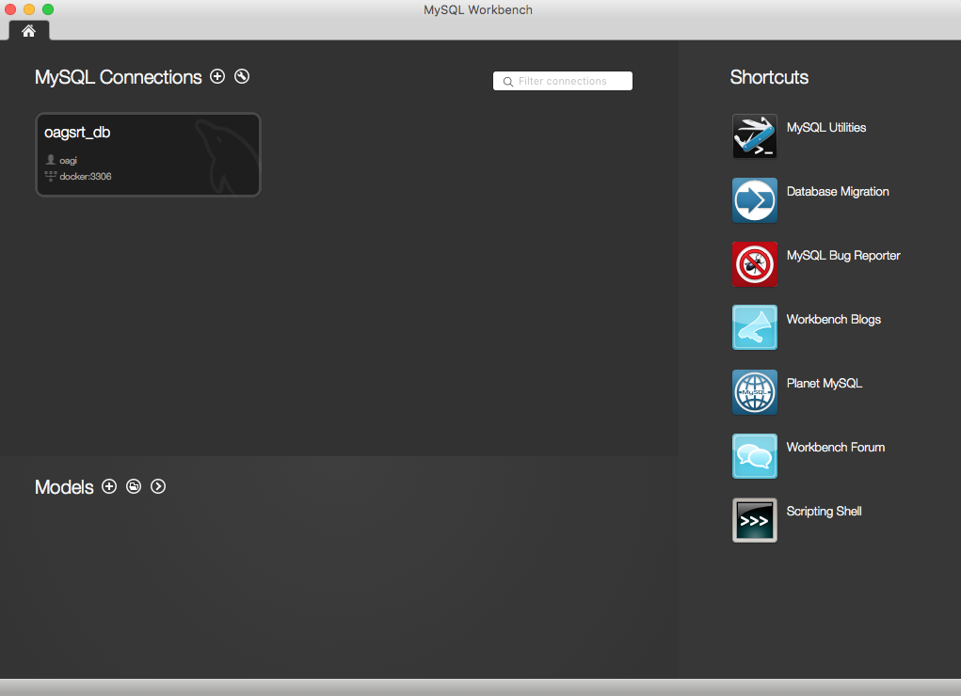

[ Figure 3.1.3. After creating new connection ]

Now, the database can be accessed. Click the box showing the database connection name created earlier. A SQL Editor will display as shown in Figure 3.1.4.

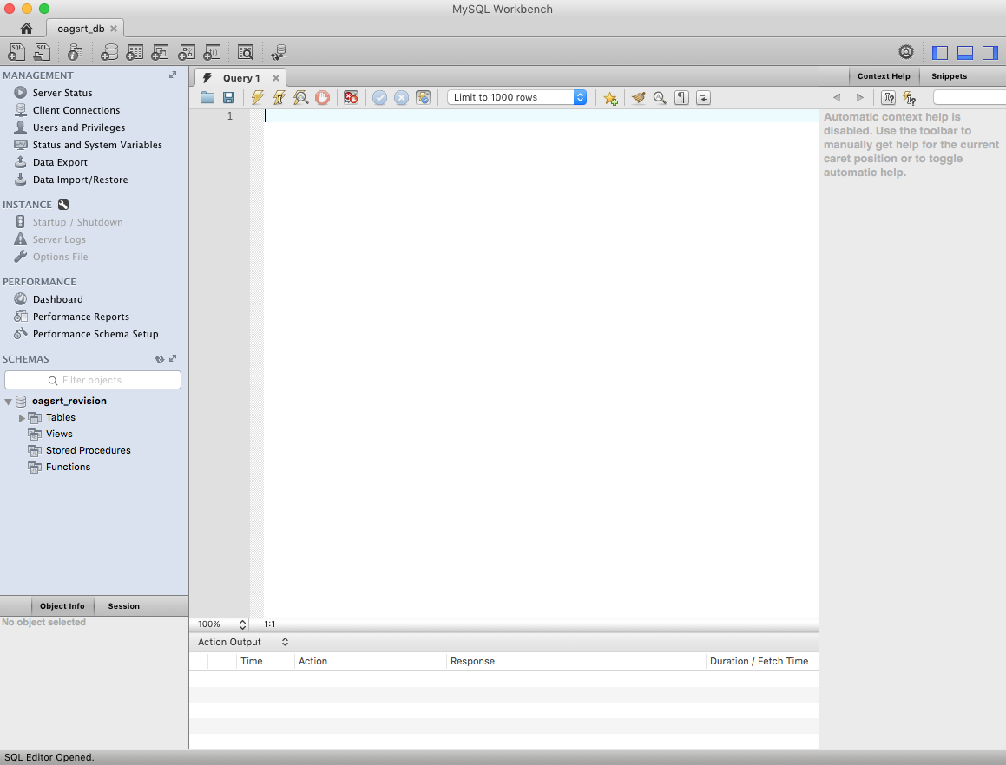

[ Figure 3.1.4. SQL Editor Screen on MySQL Workbench ]

3.1.2. Create Schema and Import Data

To create the SRT schema and Import data, use the ‘Run SQL Script’ function on File Menu.

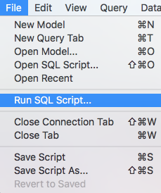

[ Figure 3.1.5. Run SQL Script… on File Menu ]

Click this menu and choose ***schema-mysql.sql*** file from your local filesystem.

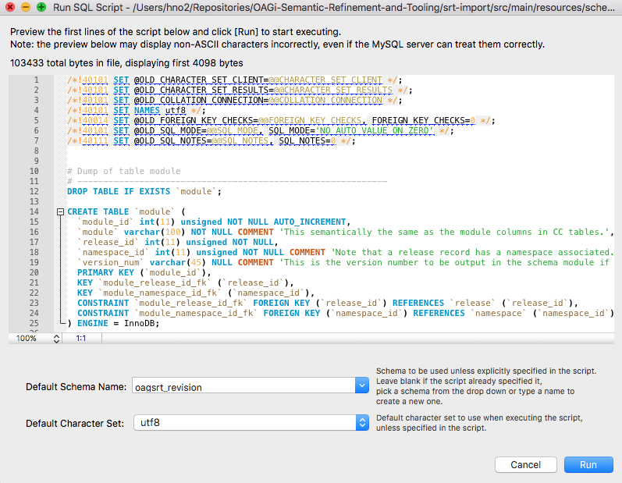

[ Figure 3.1.6. The dialog before running the schema creation script ]

Choose the default schema name and character set - *utf8* is recommended.

Finally, click the ‘Run’ button.

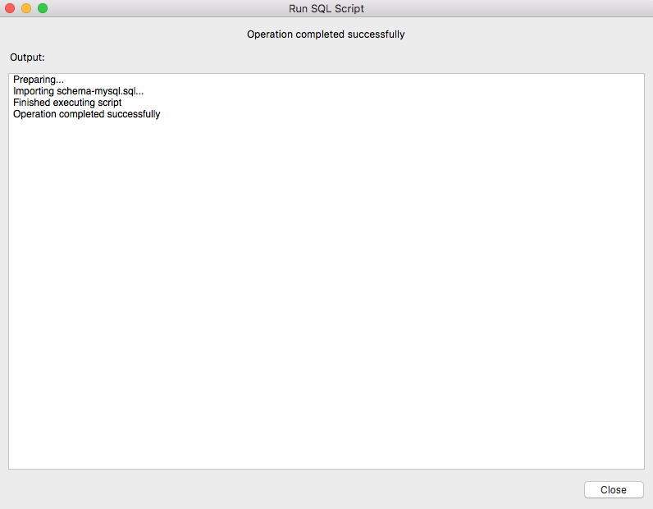

[ Figure 3.1.7. The dialog after running the script ]

Upon successful execution, you can see the tables in the selected default schema (database). In the same way, the data can be imported using the ***data-mysql.sql*** script.